# 11/12 Meeting

Date: 11/12/25

Time: 11:00am-12:00pm CDT

Attendees: Juliette Reeder, Jack Hicks, Forrest Tuschhoff, Dr. Chuck Bunting, Dr. Pavithrakrishnan Radhakrishnan

<https://youtu.be/4bxABZyb-RQ>

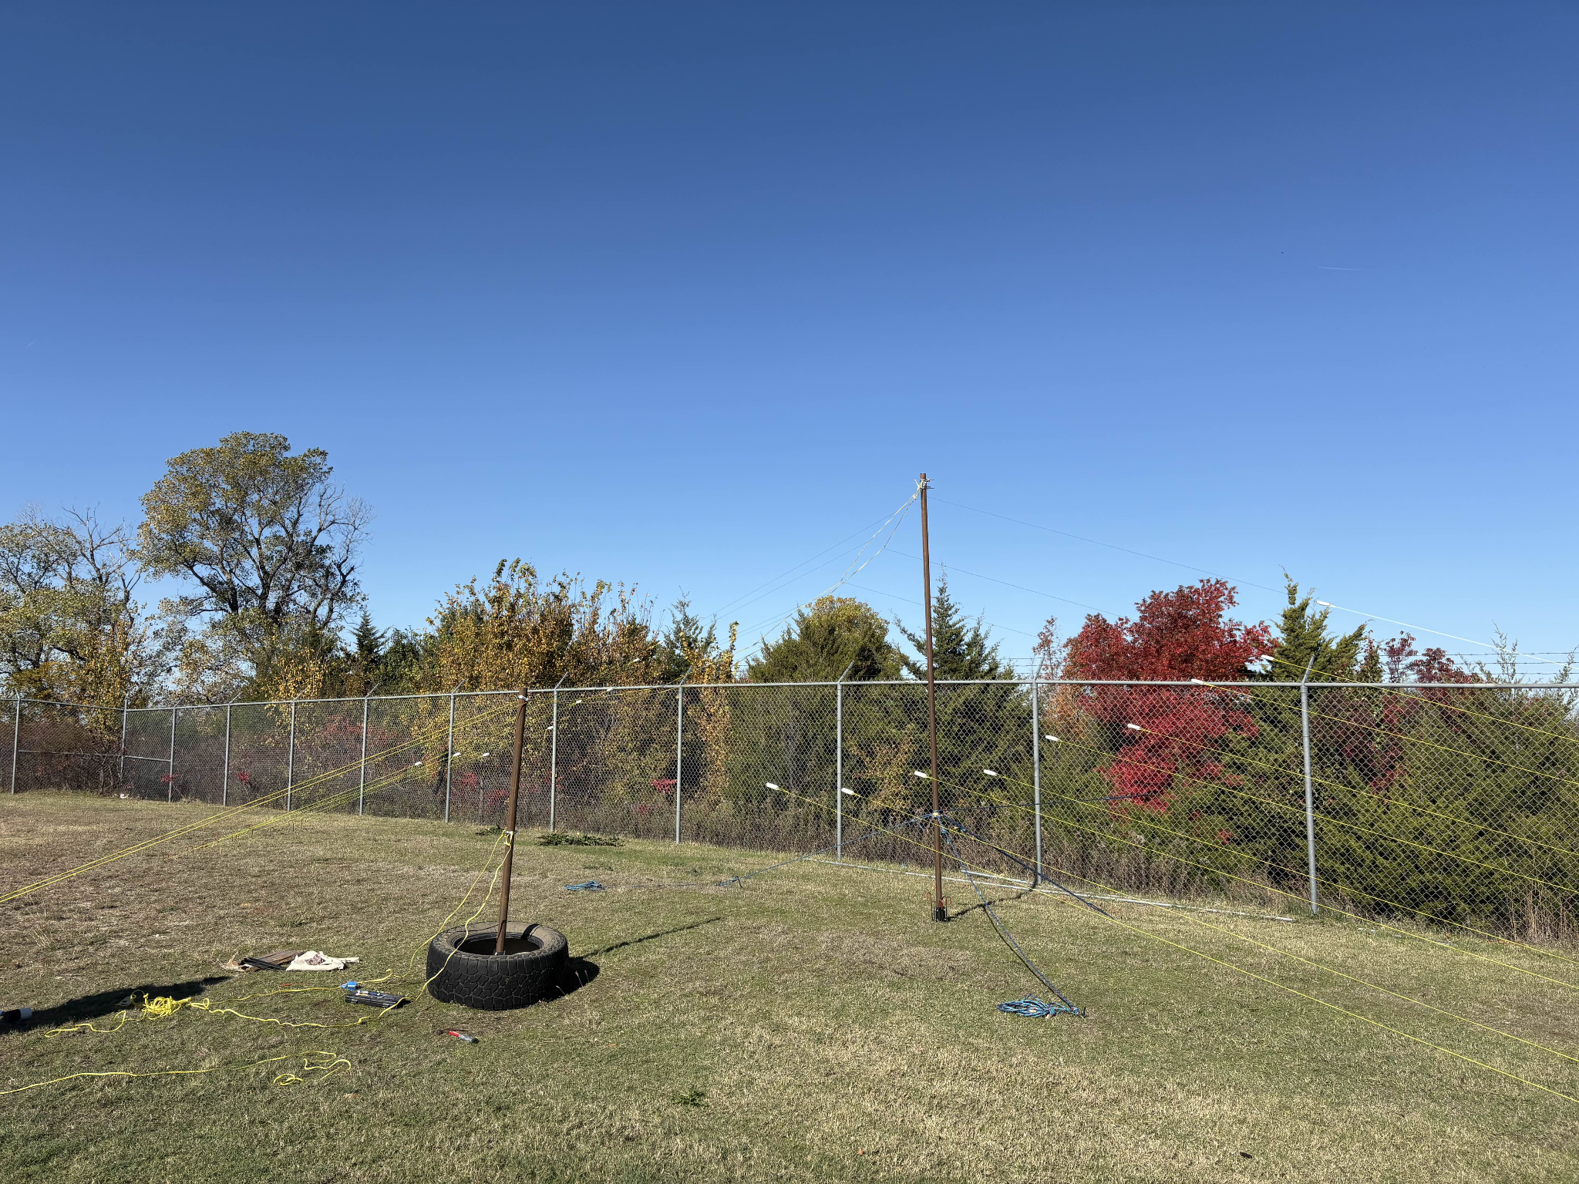

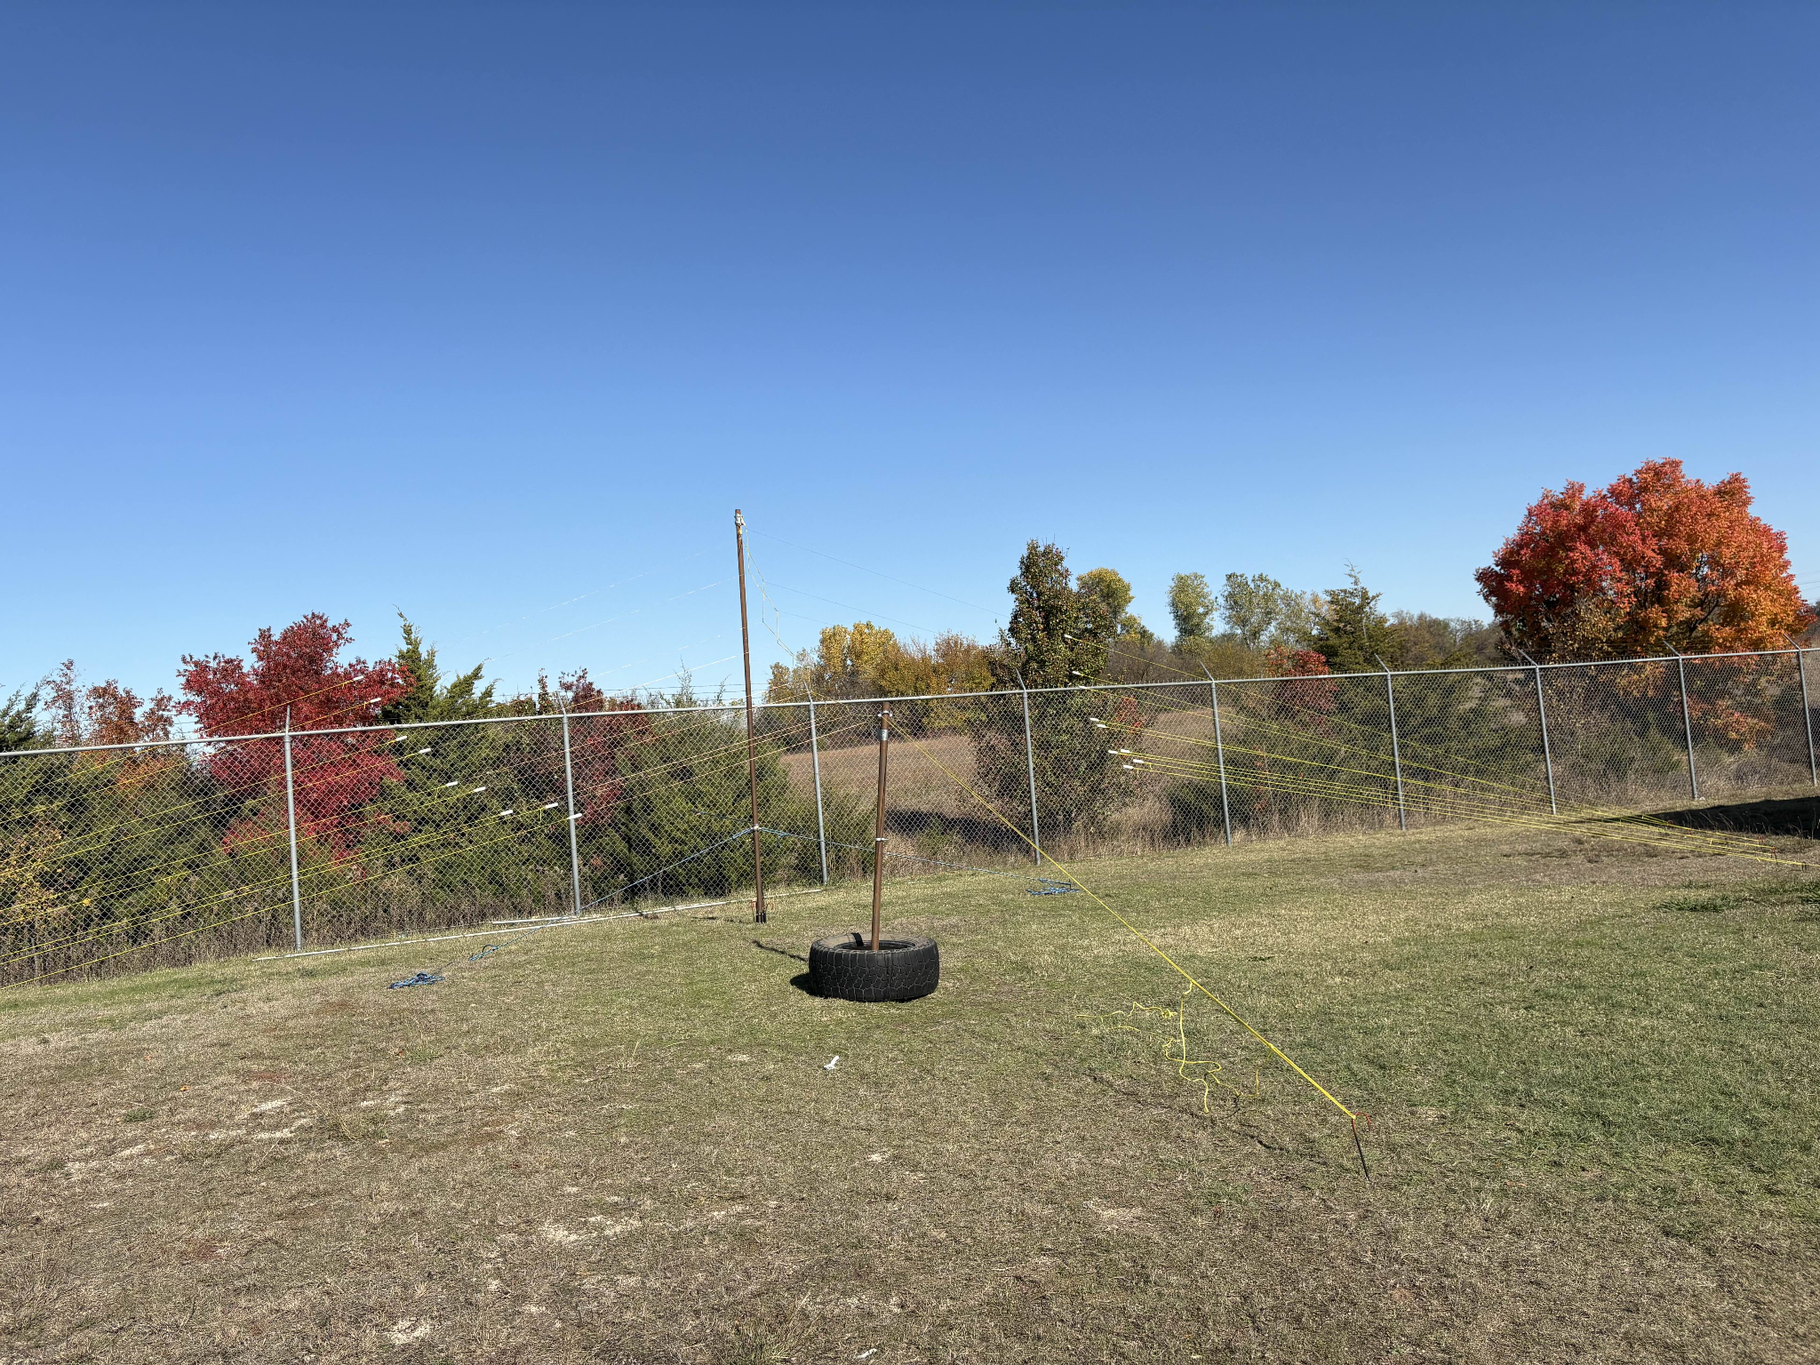

**Measurements:**

* Small LPDA proportionally close to ground
* Large LPDA
* FieldFox TODAY
* Analysis
* Error analysis
* Measurement notes:
  + 17 dBm, 28.000MHz
    - Reaches 140 V/m at end of third element in very near field
    - Minimum at boom
  + 17 dBm, 21.450MHz
    - Confirmed longest elements were excited dipoles
  + Y-axis -- back to front (feed point) polarization of E-Field
* Discuss and collect amplifier tomorrow (Thursday)

**Poster:**

* SEND TO PRINT BY 11/18 (please allow 2 business days for poster to be printed)
* <https://info.library.okstate.edu/poster-printing>
* Results
* Conclusions
* Future work
* References

**Tiny antenna:**

* Time permitting
* Define bandwidth

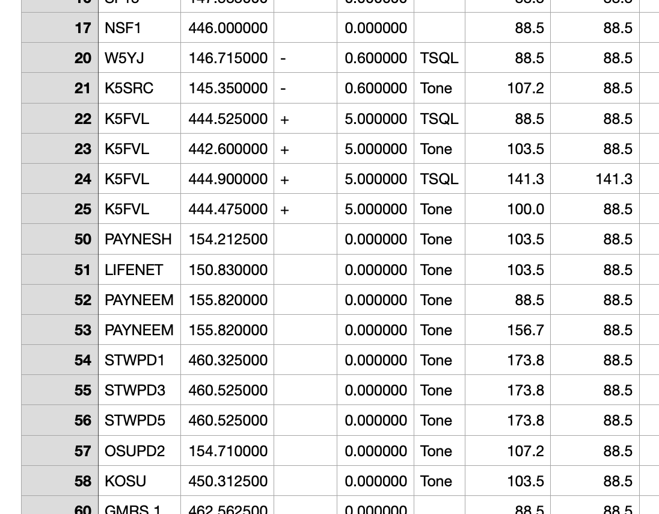

* Get materials, construct this weekend
* Nano spectrum analyzer, Baofeng radio receiver